Title: Ecological Drivers of Seedling Establishment and Survival in an upland prairie ecosystem; applications for restoration­­

**Authors:** Katherine D. Jones1 and Thomas N. Kaye1,2 ­­

1 Battelle Ecology, National Ecological Observatory Network, 1685 38th St. Suite 100, Boulder, Colorado 80301

2 Oregon State University, Department of Botany and Plant Pathology, 2082 Cordley Hall, Corvallis, Oregon 97331-2902

3 Institute for Applied Ecology, P.O. Box 2855, Corvallis, Oregon 97339

Corresponding Author: K Jones,

National Ecological Observatory Network (NEON), 1685 38th Street, Boulder, CO 80302

720-330-1550

kjones@neoninc.org

Running Title: Drivers of Seedling Establishment and Survival

Word Count: Summary - 209; Main text - 4186; Acknowledgements - 91; References - 1354; Tables and Figures - 606

Number of Tables: 2

Number of Figures: 9

Number of References: 55

**Summary**

1. We tested for evidence of competition and facilitation in a high stress environment in the Willamette Valley, Oregon, USA. We hypothesized that positive interactions would be the primary driver of establishment at our sites but that interactions likely differ between plant functional groups and between life history stages.
2. We direct seeded or planted five species of native perennial forbs of conservation concern, *Lupinus oreganus*, *Castilleja levisecta*, *Erigeron decumbens, Iris tenax* and *Sidalcea malviflora* ssp. *virgata,* into 20 experimentally manipulated plots with differing plant community structure at each of three sites.
3. Seedling establishment and survival was tracked over two growing seasons, and was correlated with estimates of cover by plant functional group, litter, bare soil and disturbance.
4. There was evidence of indirect facilitation of *L. oreganus, S. malviflora* ssp. *virgata* and *C. levisecta* by grass in the form of leaf litter. Facilitation by litter is contrary to the common perception that litter inhibits plant establishment but supports the theory that facilitation is more common in high stress sites.
5. Synthesis and applications.For restoration of degraded habitats in high stress environments, this suggests a phased approach; land managers should consider seeding target species of forbs prior to eradicating invasive grasses or after successfully establishing native grasses.

Keywords: Restoration, facilitation, competition, grassland

**Introduction**

Habitat loss and competition from non-native species are leading causes of declines in diversity (Morse 1996; Czech 1997; Wilcove *et al.* 1998). The list of threatened and endangered species is growing at an increasing rate (Pimm & Raven 2000); in some cases, whole ecosystems are at risk of being lost (Noss, LaRoe III & Scott 1995). Restoring this diversity is a major challenge facing ecologists and land managers (Dobson 1997; Hobbs & Harris 2001) and there is a clear call to answer these challenges through the direct application of ecological theory (Palmer, Ambrose & Poff 1997; Miller & Hobbs 2007).

In applied ecology, primary ecological concepts provide managers with a theoretical framework from which to develop restoration protocols based on the biology of individual species (Sarrazin & Barbault 1996; Palmer, Ambrose & Poff 1997; Zedler 2005). In plant community ecology, the stress-gradient hypothesis proposes that competitive interactions between plant species have greater importance in low or moderate stress environments and that as stress conditions increase, facilitative interactions become more prevalent (Bertness & Callaway 1994; Tielbörger & Kadmon 2000). Within a particular habitat type, effective restoration techniques will differ in locations with differing stress conditions (Padilla & Pugnaire 2006) and it is likely that interactions will differ among life history stages (Brown & Van Staden 1997; McPeek & Peckarsky 1998; Maestre, Valladares & Reynolds 2005). Even under a particular stress environment, interspecific plant interactions differ between functional groups because resource use can vary among these groups (Hooper 1997). In prairie systems, grasses, especially non-native invasive species, tend to be taller and faster growing than many native forbs (Blossey & Notzold 1995; Wilson 1998; Wilson & Clark 2001) and therefore frequently suppress native forbs regardless of stress condition. Disturbance, especially herbivory, can also have significant effects on plant community structure and may alter effects of either competition or facilitation between plant species (Hambäck & Beckerman 2003; Brooker *et al.* 2006). Successful conservation efforts, especially reintroduction of species with important ecosystem functions or species of particular conservation concern (Srivastava & Vellend 2005; Isbell *et al.* 2011) will be achieved through identifying and applying ecological theories that drive community structure and ecosystem dynamics at a particular location (Thorpe & Stanley 2011). Also, conservation of species *interactions* is essential to successful ecosystem restoration (Soulé *et al.* 2003); individual species reintroductions therefore, should be conducted within an ecosystem context.

Temperate latitudes have experienced some of the greatest losses of biodiversity due to intense development and exploitation by humans (Noss, LaRoe III & Scott 1995). Grasslands and savannas (prairies) in particular are among the most endangered ecosystems in the United States based on their decline, current extent, imminence of threat, and number of associated threatened and endangered species (Noss & Peters 1995; Noss 2000). The Willamette Valley is no exception with significant loss of native ecosystems. Prior to European settlement, this region was a mosaic of coniferous forests, oak savannas and grasslands with high plant and animal diversity. Habitat loss, caused by conversion to agriculture, urbanization and natural succession to shrubland and forest due to fire suppression has reduced native habitats to a fraction of their pre-settlement extent (Alverson 2005). Before 1850, prairies covered approximately 30% (409,000 hectares) of the valley floor (Altman *et al.* 2001) and upland prairies accounted for approximately 277,000 hectares, two-thirds of Willamette Valley prairies (U.S. Fish and Wildlife Service 2000). Today, less than 0.5% remains (Wilson *et al.* 2003). Because of this severe habitat loss, the upland prairie ecosystem of western Oregon is one of the most endangered in the United States (Noss, LaRoe III & Scott 1995). We conducted our experiments in prairies at the southern end of the Willamette Valley/Puget Trough/Georgia Basin (WPG) Ecoregion, which spans almost 600 km from north to south forming a gradient with low stress (high productivity, soil moisture, fertility and organic matter) in northern sites and high stress (low productivity, etc.) in southern sites (Richardson *et al.* 2012). All of the sites included in this study are located in the southern portion of this ecoregions and are characterized as high stress environments.

The research presented here was designed to identify interactions, positive and negative, that drive establishment of native species of conservation concern in upland prairies of western Oregon, USA. We focused on five native plant species that are threatened or endangered and provide essential ecosystem functions for two endangered butterflies, Fender’s blue (*lcaricia icarioides fenderi*) and Taylor’s checkerspot (*Euphydryas editha taylori*). We asked the question, which plant community interactions determine establishment and survival of these forbs?

In this experiment, we tested several hypotheses:

H1: Plant community interactions in this region are dominated by facilitation at the seedling stage with established plants protecting vulnerable seedlings. Competition is likely more prevalent at later life history stages as plants mature and develop similar resource requirements to the established plant community.

H2: Plant community interactions differ between functional groups; grasses are more likely than established forbs to exert a competitive effect on establishment of planted forb species.

H3: Disturbance by herbivores and burrowing rodents will have a negative effect on establishment and will obscure plant-plant interactions if incidence is high.

We broadcast seeds and planted vegetative plugs, transplants, into manipulated prairie communities to address these hypotheses.

**Methods**

*Study System*

We conducted our experiments at three study sites (Figure 1), two at William L. Finley National Wildlife Refuge, Pigeon Butte (44°23.9’ N, 123°19.2 W) and Bellfountain (44°24.2’ N, 123°20.9’ W ), and one at Fort Hoskins Historic Park (44°40.8’ N, 123°27.8’ W) managed by Benton County, Oregon. Each site had received prior habitat restoration treatments from 2006 to 2009 as part of a larger replicated regional study to test the effectiveness of a variety of prairie restoration treatments (Stanley et al., 2008) on 5 x 5 m experimental units. These prior treatments resulted in a wide range of community composition and forb, grass, and litter cover (Stanley, Kaye & Dunwiddie 2008, 2011; Stanley, Dunwiddie & Kaye 2011; Richardson *et al.* 2012) at each site into which we planted our target species. Elevation at the study sites ranges from 112-138 m above mean sea level. Soils are all moderately deep to very deep and well-drained, and formed from colluvium and residuum derived from basalt, igneous bedrock or sedimentary rocks. All sites have a Mediterranean-type climate, characterized by mild wet winters and dry summers with an average annual precipitation of 171 cm. The two years we made observations, 2010 and 2011, experienced spring temperatures that were cooler than average with above average precipitation in this region.

Our study species included Kincaid’s lupine (*Lupinus oreganus* A. Heller), golden paintbrush (*Castilleja levisecta* Greenm.), roughleaf iris (*Iris tenax* Douglas ex Lindl.), and rose checkermallow (*Sidalcea malviflora* (DC.) A. Gray ex Benth. ssp. *virgata* (Howell) C.L. Hitchc.). *L. oreganus,* and *C. levisecta* are threatened species in the Willamette Valley. *Iris tenax* and *S. malviflora* ssp. *virgata* were also included because of their value as nectar resources for endangered butterflies (Schultz & Dlugosch 1999; Schultz 2001) (see Table 1 for details). Plant nomenclature follows the Oregon Flora Project (Cook and Sundberg (eds.) 2011).

*Experimental Design*

To test for effects of associated vegetation on plant establishment, we seeded or planted plugs of our target species into 20 manipulated plant communities at each site. We established 0.5 x 2 meter plots in each of the previously manipulated treatment units (consistently in a quadrant of the plot that had been seeded with native forbs and grasses in 2007). We broadcast seeds of *L. oreganus* and *S. virgata* into each plot in November of 2009. The number of seeds sown varied by species. Viability of *S. malviflora* ssp. *virgata* seed was estimated at 84% (commercially reported live seed) so we sowed 119 seeds per plot to achieve an average sowing rate of 100 viable seeds. Note: we also seeded, *I. tenax* (100 live seeds per plot) and *E. decumbens* (1000 seeds per plot by weight) into the plots but only 29 seedlings of *I. tenax* and only 13 seedlings of *E. decumbens* emerged during this experiment making it difficult to test for any community effects on these species, so they are not discussed further in this paper. We sowed 200 *L. oreganus* seeds in each plot. Previous germination tests showed that seeds of this species have over 95% viability (Kaye & Kuykendall 2001), so no adjustment was made to seed numbers. Half of the seeds in each plot were scarified prior to sowing as part of a seed pre-treatment experiment, such that 100 seeds of each type were sown in each 0.5 x 1.0 m half of the plots. The results of which are reported elsewhere (Jones 2012) , but we retained this split-plot design in our analyses of each species. In addition, 50 *L. oreganus* seeds were broadcast in one 0.5 x 0.5 m plot in each treatment unit in November 2006. These seedings did not overlap with the plots we established in 2009.

We planted five plugs each of *C. levisecta* and *I. tenax* inJune and November of 2010, respectively. Plugs of *C. levisecta* were planted at Bellfountain only due to limited availability of this species, while *I. tenax* was planted at all three sites. In both cases, plugs were planted on 50 cm spacing along one edge of the 0.5 x 2 m plots, with *I. tenax* and *C. levisecta* on opposite sides at Bellfountain.

*Data Collection*

*Cover estimates*

We conducted ocular estimates of cover to the nearest 1% of grasses, forbs, moss, litter, bare soil and soil disturbed by rodents May-June of 2010 and June-July 2011 in each half of the 0.5 x 2.0 m plots. Litter depth was measured at 10 points in each half of the 0.5 x 2.0 m plots. Estimates were made for each growing season. In June of 2011 we estimated percent cover of grasses, forbs, moss, litter, bare soil, and disturbance in each 0.5 x 0.5 m plot seeded with *L. oreganus* in 2006.

*Establishment by seed*

We counted the number of leaves and mapped the location of each target species seedling in each half of the 0.5 x 2.0 m plot in April and May of 2010 and again in May 2011. The location of each seedling within the plot was mapped to the nearest centimeter and recorded on paper datasheets to enable annual re-measurement.

In 2011, we measured *L. oreganus* from seeds sown in 2006 by counting the number of lupine leaves present in each 0.5 x 0.5 m plot. After 5 years of growth, many individuals had grown together and single individuals were difficult to distinguish from one another. We used the number of *L. oreganus* leaves as a measure of overall growth of the 50 seeds sown in 2006.

*Transplants*

Plant survival of both transplanted species was recorded in May 2011. The number of leaves and the length of the longest leaf blade were measured for each transplanted *I. tenax*. *C. levisecta* produces multiple shoots from the ground; the length of each shoot was measured and flowering status was recorded.

*Statistical Analyses*

Data were analyzed using R statistical software, version 2.14 (2011). Our response variables were the proportion of seeds that establish and proportion of established seeds or vegetative transplants that survived in our experimental plots. Our explanatory variables were percent cover of existing vegetation by functional group and average litter depth, measured in centimeters.

We used Analysis of Variance (ANOVA) to test for differences in initial establishment and survival rates between the three sites and, although establishment did not always differ significantly by site, site was a blocking factor and therefore was accounted for in all Multiple Regression models. We used Simple Linear Regression to test for community interactions with planted *C. levisecta* plugs, and we used Multiple Linear Regression to test for the effect of surrounding vegetation on initial establishment and survival of seeds planted in 2009 and *I. tenax* plugs planted in 2010.

Although we determined that there was no density dependence for this species, in 2011 survival was analyzed for each split plot to retain the 0.5 m resolution of cover estimates for all of the seeds with a shared treatment history. Cover estimates were averaged across the 0.5 x 1 m split-plot for *L .oreganus* and across the whole 0.5 x 2 m plot for all other species. Though the range of cover conditions in these plots was strongly influenced by previous treatments (Richardson *et al.* 2012), we characterized the community composition of each plot individually rather than grouping by treatment history. Given this study design, we cannot separate effects of community components from treatment history.

**Results**

*Community Components*

Grass cover in our plots ranged from 0 to 80% and differed by site (f=5.77, df=2, p=0.03, ANOVA F-test). Cover by forbs ranged from 19% to 93% and did not differ significantly by site (f=5.77, df=2, p=0.34). Total cover of vascular plants, the sum of grass and forb estimates, ranged from 42 to 121% and did not differ by site (f=0.32, df=2, p=0.72). Litter depth ranged from 0.25 to 5.10 centimeters and was closely correlated with grass cover (p<0.0001; Figure 2). Disturbed area of plots, caused primarily by moles, ranged from 0 to 50% and differed by site (f=11.35, df=2, p=0.0001).

*Lupine*

*Establishment*

*L. oreganus* establishment did not differ among sites (p=0.78). Seedling establishment was positively correlated with litter depth after accounting for site (p=0.03, R2=0.11, see Table 2 for all regression models). This correlation was significant individually at Pigeon Butte (p=0.06) and Ft. Hoskins (p=0.069), but not at Bellfountain (p=0.29, Figure 3).

*Seedling survival*

Survival to 2011 of plants that established in 2010 differed by site (f=14.97, df=2, p<0.0001), but did not depend on scarification (f=2.25, df=1, p=0.33), nor on the number of plants that established in 2010 (f=0.29, df=1, p=0.48 ANOVA F-test).

Survival was positively correlated with litter depth after accounting for site (p=0.05, R2=0.30; Figure 4). Disturbance by moles was strongly negatively correlated with survival after accounting for site (p=0.0005, R2=0.39, Figure 4).

Only half of the plots at Bellfountain and Ft. Hoskins that were planted with *L. oreganus* in 2006 still had lupine present in 2011. Plots without lupine present had about 26% higher grass cover than plots with lupine (p=0.001, 95% CI 11%-41%). Of the plots with lupine, median leaf number was positively correlated with litter depth (p=0.07) after accounting for site. All other community factors appeared to have a neutral effect on median leaf number (Table 3).

*Sidalcea malviflora* ssp. *virgata*

*Establishment*

Initial establishment of *S. malviflora* ssp. *virgata* differed by site (f=7.49, df=2, p=0.002 ANOVA F-test). After accounting for site, none of the community components we measured were correlated with initial establishment in our multiple regression models.

*Seedling survival*

Survival of seedlings that established in 2010 did not differ by site (f=1.59, df=2, p=0.21 ANOVA F-test). After accounting for site, litter depth was positively correlated (p=0.004) with seedling survival (Figure 5) and there was equivocal evidence that bare ground (p=0.07) and convincing evidence that incidence of disturbance by moles (p=0.007), were negatively correlated with survival.

*Castilleja levisecta*

Establishment of *C. levisecta* plugs planted in 2010 was not correlated with cover of any of the functional groups we measured, but survival to 2011 was positively correlated with grass cover (p=0.07), total cover of grasses and forbs (p=0.04), and litter depth (p=0.01; Figure 6) and negatively correlated with bare ground (p=0.008) and disturbance by moles (p=0.03).

*Iris tenax*

*Survival of transplants*

There was an average of 76% survival of transplanted *Iris*. Survival differed by site (f=4.26, df=2, p=0.019, ANOVA F-test), primarily because nearly 100% survived at Pigeon Butte. Due to the generally high survival rate, we were unable to detect a significant positive or negative effect of any community component.

**Discussion**

*Facilitation and Competition*

Plant establishment and survival in this prairie system tended to be affected more by facilitation than competition. The indirect effect of grass through litter accumulation was the strongest potential driver of seedling establishment of *Lupinus oreganus* and seedling survival of *Sidalcea malviflora* ssp. *virgata* at our sites. Establishment of *L. oreganus*, and *S .malviflora* was positively correlated with litter accumulation. Survival in the second year for *L. oreganus, S. malviflora* ssp. *virgata*, and *Castilleja levisecta* was also positively correlated with litter depth. We saw potentially positive interactions with grass cover (as a direct effect), moss and total vegetative cover (Table 2) for *C. levisecta* at Bellfountain and *L. oreganus* and *S. malviflora* ssp. *virgata* at individual sites.

Litter is generally considered to have an inhibitory effect on seed germination and establishment though this trend is weaker in grasslands than in forest or forb dominated environments (Ryser 1993; Xiong & Nilsson 1999). Both the physical and chemical environments are affected by the presence of plant litter (Facelli & Pickett 1991; Loydi *et al.* 2013). Litter can intercept light, limit temperature extremes through effects of insulation or shading and help conserve soil moisture (Amatangelo, Dukes & Field 2008).

In Willamette Valley prairies, litter has been shown to have both positive and negative effects on seed establishment, and the effect is not consistent across species in this system (Clark & Wilson 2000). Maret and Wilson (2005) found that litter suppressed establishment of broadcast seeds in Western Oregon grasslands; the negative effects of litter on seedling establishment in their study may be related to small seed size and the mechanical affect of litter preventing seed-to-soil contact. Jensen and Guteknust (2003) and Lönnberg and Eriksson (2013) found that in the presence of litter, seedling establishment was positively correlated with seed size. Seeds of *L. oreganus* and *S. malviflora* ssp. *virgata* are relatively large (0.015-0.023 g/seed and 0.003-0.005 g/seed respectively (Bartow 2016)) compared with seeds of *E. decumbens* (0.0001 g/seed (Bartow 2016)) and are unappendanged, which may have made them more successful at passing through the litter layer to achieve soil contact.

*Differences in interaction by functional group*

We found no indication that grass inhibited establishment in the first two years of any of the species we seeded in our plots. In fact we found the opposite; litter depth, an indirect effect of grass was positively correlated with increased establishment and survival of *L. oreganus*, survival of *S. malviflora* ssp. *virgata* and second year survival of *C. levisecta.*

Negative effects we measured for establishment and survival of seedlings in their first two years were correlated with abiotic factors associated with disturbance and bare ground. This indicates that the *lack* of neighbors to interact with or burial and removal by burrowing rodents may be negatively affecting the ability of some prairie plants to establish and persist. Direct interactions with biotic community components such as grass, forb and moss cover appear to be primarily neutral in the early stages of establishment but may tend towards competition at later life history stages.

*Competition and facilitation at different life history stages*

In our study, the number of leaves was a reasonable proxy foroverall performance of *L. oreganus* because it was correlated with reproductive potential. With respect to leaf number, we saw a potential shift from neutrality to competition with grass cover in five-year old lupine compared to seedlings, but litter depth still was positively correlated with overall performance. Wolkovich et al (2009) demonstrated how litter alters the biotic and abiotic environment and enhances growth of adult *Artemisia californica,* though non-native grasses likely interacted competitively with young *A. californica*. We may see something similar where litter in our study system interacts positively with our species at both the seedling and adult stages but that the net effect of facilitation and competition shifts at an intermediate life history stage (Figure 8A).

We did not have mature individuals for any of the other species we tested with which to compare this trend but we expect that transitions from facilitation or neutrality to a competitive relationships (Figure 8B), especially with grass, may occur for other species as well. Though facilitation is occurring, the shift from facilitative to competitive interactions over the life on an individual may correspond with an overall negative effect on the population over time (Williams & Crone 2006).

*Iris tenax*

Once established by transplant, *Iris tenax* had such a high survival rate that it was not possible to correlate its success with any community component. Like many irises, *I. tenax* is a clonal species (Wilson 2001) and the seeds appear to have dormancy (Jones & Kaye 2014). Because of this dormancy, for restoration purposes, seed may not be the most efficient way to establish *Iris* (Volis, Blecher & Sapir 2007), and transplants may be the preferred method for establishing this species.

*Biological relevance*

Although our results are suggestive statistically of positive or negative interactions with community components, some of the effects we observed were weak. In our regression analysis, our strongest positive signals came from the indirect interaction of target species with grass in the form of litter depth. Other community factors such as cover by grasses, forbs and total cover had minor slopes (see for example Figure 7). Though these slopes appear to be nearly flat in some cases, they still provide evidence that suggests a facilitative interaction between these community factors and the target species. The winters of 2010 and 2011 were mild; they were wetter and cooler than the average for the Willamette Valley. If, as Callaway (1997) posits, facilitative effects increase as abiotic stress increases, we’d expect the positive interactions we observed to be even stronger in warmer, drier years.

*Implications for Management*

Unfortunately, there is no silver bullet or universal prescription for ecosystem restoration. Effective restoration strategies must be goal driven (Zedler 2005), therefore strategies must differ depending on the scale at which managers are working. In the case of target species augmentation or reintroduction, the management strategy needs to be tailored to the individual species. In stressful sites, for medium to large-seeded perennial forbs that we tested, *Lupinus* and *Sidalcea* seeding should occur prior to removal of undesirable grass species or after successful establishment of native grasses. Since litter from grasses appears to enhance establishment of these species, we recommend leaving existing litter in place until a couple years after seeding. Mowing to control tall invasive grasses may be implemented if cut material is left on the ground. Targeted removal of invasive grasses should wait until target restoration species are established unless litter addition is included in the management activities. Though removal of invasive grasses may be postponed, it appears that it is a necessary step at some point to establish sustainable populations.

Seeding may not be the ideal method for introducing *Iris tenax*; managers should consider greenhouse propagation and transplanting of this species.

Disturbance by moles which dig up, eat, or bury seedlings was the strongest single factor that limited establishment of *Lupinus* and *Sidalcea*. We recommend managers survey restoration sites for burrowing rodents prior to reintroduction. If rodent populations are high, it would be wise to take steps to mitigate the detrimental effects of herbivory and soil disruption that these mammals have on establishing seedlings; rodent exclosures, removal of rodents, increased seeding rates, or preferentially selecting sites with lower abundance of moles may increase the chances of success.

Plant reintroduction will be more successful by taking the time to characterize the stress environment of restoration sites and developing reintroduction strategies that work with the unique conditions of the site and the individual requirements of the species to capitalize on interactions between plant functional groups.

**Acknowledgments**

We thank Drs. Dave Pyke, Aaron Liston and Michael Huber for comments on initial drafts of this manuscript. Access to research sites and research infrastructure was provided by the USFWS Willamette Valley Refuge Complex and the Institute for Applied Ecology. This work was supported financially by Oregon State University Department of Botany and Plant Pathology, US Fish and Wildlife Service, the Native Plant Society of Oregon Willamette Chapter, and the Portland Garden Club. Seeds and transplants were provided by the Institute for Applied Ecology and USDA NRCS Corvallis Plant Materials Center.

**Data Accessibility**

Field data, including demographic data on seedling establishment and survival, survival of planted *C. levisecta* and cover estimates have been archived in figshare, under doi: https://dx.doi.org/10.6084/m9.figshare.3580872.v2.

**References**

Altman, B., Hayes, M., Janes, S. & Forbes, R. (2001) Wildlife of westside grassland and chaparral habitats. Pages 261-291. *D.H. Johnson and T.A. O’Neil, Managing Directors. Wildlife-habitat Relationships in Oregon and Washington*, p. 736. Oregon State University Press, Corvallis, OR.

Alverson, E. (2005) Preserving prairies and savannas in a sea of forest: A conservation challenge in the Pacific Northwest. *Plant Talk*, **40**, 23–27.

Amatangelo, K.L., Dukes, J.S. & Field, C.B. (2008) Responses of a California annual grassland to litter manipulation. *Journal of Vegetation Science*, **19**, 605–612.

Bartow, A. (2016) *Native Seed Production Manual for the Pacific Northwest*. USDA NRCS Corvallis Plant Materials Center.

Bertness, M.D. & Callaway, R. (1994) Positive interactions in communities. *Trends in Ecology & Evolution*, **9**, 191–193.

Blossey, B. & Notzold, R. (1995) Evolution of increased competitive ability in invasive nonindigenous plants: a hypothesis. *Journal of Ecology*, **83**, 887–889.

Brooker, R.W., Scott, D., Palmer, S.C.F. & Swaine, E. (2006) Transient facilitative effects of heather on Scots pine along a grazing disturbance gradient in Scottish moorland. *Journal of Ecology*, **94**, 637–645.

Brown, N. & Van Staden, J. (1997) Smoke as a germination cue: a review. *Plant Growth Regulation*, **22**, 115–124.

Callaway, R.M. (1997) Positive interactions in plant communities and the individualistic-continuum concept. *Oecologia*, **112**, 143–149.

Clark, D. & Wilson, M. (2000) Promoting regeneration of native species in Willamette Valley upland prairies. *Report to USDI Fish and Wildlife Service and Oregon Natural Heritage Program. Corvallis (OR): Oregon State University*.

Cook, T. & Sundberg (eds.), S. (2011) Oregon Vascular Plant Checklist.

Czech, B. (1997) Distribution and Causation of Species Endangerment in the United States. *Science*, **277**, 1116–1117.

Dobson, A.P. (1997) Hopes for the Future: Restoration Ecology and Conservation Biology. *Science*, **277**, 515–522.

Facelli, J.M. & Pickett, S.T. (1991) Plant Litter: Its Dynamics and Effects on Plant Community Structure. *The Botanical Review*, **57**, 1–32.

Hambäck, P.A. & Beckerman, A.P. (2003) Herbivory and plant resource competition: a review of two interacting interactions. *Oikos*, **101**, 26–37.

Hobbs, R.J. & Harris, J.A. (2001) Restoration ecology: repairing the earth’s ecosystems in the new millennium. *Restoration ecology*, **9**, 239–246.

Hooper, D.U. (1997) The Effects of Plant Composition and Diversity on Ecosystem Processes. *Science*, **277**, 1302–1305.

Isbell, F., Calcagno, V., Hector, A., Connolly, J., Harpole, W.S., Reich, P.B., Scherer-Lorenzen, M., Schmid, B., Tilman, D., van Ruijven, J. & others. (2011) High plant diversity is needed to maintain ecosystem services. *Nature*, **477**, 199–202.

Jensen, K. & Gutekunst, K. (2003) Effects of litter on establishment of grassland plant species: the role of seed size and successional status. *Basic and Applied Ecology*, **4**, 579–587.

Jones, K. (2012) *Factors Affecting Establishment and Germination of Upland Prairie Species of Conservation Concern in the Willamette Valley, Oregon (Masters Thesis). Oregon State University, Corvallis, OR.* Oregon State University, Corvallis, Oregon.

Jones, K.D. & Kaye, T.N. (2014) Factors Influencing Germination of a Functionally Important Grassland Plant, Iris tenax. *PloS one*, **9**, e90084.

Kaye, T. & Kuykendall, K. (2001) Effects of scarification and cold stratification on seed germination of Lupinus sulphureus ssp. kincaidii. *Seed science and technology*, **29**, 663–668.

Lönnberg, K. & Eriksson, O. (2013) Rules of the seed size game: contests between large-seeded and small-seeded species. *Oikos*, **122**, 1080–1084.

Loydi, A., Eckstein, R.L., Otte, A. & Donath, T.W. (2013) Effects of litter on seedling establishment in natural and semi-natural grasslands: a meta-analysis. *Journal of Ecology*, **101**, 454–464.

Maestre, F.T., Valladares, F. & Reynolds, J.F. (2005) Is the change of plant-plant interactions with abiotic stress predictable? A meta-analysis of field results in arid environments. *Journal of Ecology*, **93**, 748–757.

Maret, M.P. & Wilson, M.V. (2005) Fire and litter effects on seedling establishment in western Oregon upland prairies. *Restoration Ecology*, **13**, 562–568.

McPeek, M.A. & Peckarsky, B.L. (1998) Life histories and the strengths of species interactions: combining mortality, growth, and fecundity effects. *Ecology*, **79**, 867–879.

Miller, J.R. & Hobbs, R.J. (2007) Habitat Restoration—Do We Know What We’re Doing? *Restoration Ecology*, **15**, 382–390.

Morse, L.E. (1996) Plant Rarity and Endangerment in North America. *Restoring Diversity: Strategies for Reintroduction of Endangered Plants. Edited by DA Falk, CI Millar and M Olwell*, pp. 7–22. Island Press, Washington, D.C. and Covelo, California.

Noss, R.F. (2000) High-risk ecosystems as foci for considering biodiversity and ecological integrity in ecological risk assessments. *Environmental Science & Policy*, **3**, 321–332.

Noss, R.F., LaRoe III, E.T. & Scott, J.M. (1995) *Endangered Ecosystems of the United States: A Preliminary Assessment of Loss and Degradation*. Biological Report, National Biological Service, Washington, D.C.

Noss, R.F. & Peters, R.L. (1995) *Endangered Ecosystems of the Unites States: A Status Report and Plan for Action.* Defenders of Wildlife, Washington, DC.

Padilla, F.M. & Pugnaire, F.I. (2006) The role of nurse plants in the restoration of degraded environments. *Frontiers in Ecology and the Environment*, **4**, 196–202.

Palmer, M.A., Ambrose, R.F. & Poff, N.L.R. (1997) Ecological theory and community restoration ecology. *Restoration ecology*, **5**, 291–300.

Pimm, S.L. & Raven, P. (2000) Biodiversity: extinction by numbers. *Nature*, **403**, 843–845.

R Development Core Team. (2011) *R: A Language and Environment for Statistical Computing.* R Foundation for Statistical Computing., Vienna, Austria.

Richardson, P.J., MacDougall, A.S., Stanley, A.G., Kaye, T.N. & Dunwiddie, P.W. (2012) Inversion of plant dominance-diversity relationships along a latitudinal stress gradient. *Ecology*, **93**, 1431–1438.

Ryser, P. (1993) Influences of neighbouring plants on seedling establishment in limestone grassland. *Journal of Vegetation Science*, **4**, 195–202.

Sarrazin, F. & Barbault, R. (1996) Reintroduction: challenges and lessons for basic ecology. *Trends in Ecology & Evolution*, **11**, 474–478.

Schultz, C.B. (2001) Restoring resources for an endangered butterfly. *Journal of Applied Ecology*, **38**, 1007–1019.

Schultz, C.B. & Dlugosch, K.M. (1999) Nectar and hostplant scarcity limit populations of an endangered Oregon butterfly. *Oecologia*, **119**, 231–238.

Soulé, M.E., Estes, J.A., Berger, J. & Del Rio, C.M. (2003) Ecological effectiveness: conservation goals for interactive species. *Conservation Biology*, **17**, 1238–1250.

Srivastava, D.S. & Vellend, M. (2005) BIODIVERSITY-ECOSYSTEM FUNCTION RESEARCH: Is It Relevant to Conservation? *Annual Review of Ecology, Evolution, and Systematics*, **36**, 267–294.

Thorpe, A.S. & Stanley, A.G. (2011) Determining appropriate goals for restoration of imperiled communities and species. *Journal of Applied Ecology*, **48**, 275–279.

Tielbörger, K. & Kadmon, R. (2000) Temporal environmental variation tips the balance between facilitation and interference in desert plants. *Ecology*, **81**, 1544–1553.

U.S. Fish and Wildlife Service. (2000) *Endangered and Threatened Wildlife and Plants; Endangered Status for ‘Erigeron decumbens’ var. ‘decumbens’ (Willamette Daisy) and Fender’s Blue Butterfly (‘Icaricia Icarioides Fenderi’) and Threatened Status for ‘Lupinus sulphureus’ ssp. ‘kincaidii’ (Kincaid’s Lupine)*.

Volis, S., Blecher, M. & Sapir, Y. (2007) *Iris Atrofusca of the Northern Negev: Population Differences and Creation in Situ Gene Banks. Report to the Israel Nature and Parks Authority*. Ben-Gurion University of the Negev.

Wilcove, D.S., Rothstein, D., Dubow, J., Phillips, A. & Losos, E. (1998) Quantifying threats to imperiled species in the United States. *BioScience*, **48**, 607–615.

Williams, J.L. & Crone, E.E. (2006) The impact of invasive grasses on the population growth of Anemone patens, a long-lived native forb. *Ecology*, **87**, 3200–3208.

Wilson, M.V. (1998) Upland prairie. *Chapter In: Part I US Fish and Wildlife Service Willamette Basin Recovery Plan. Portland (OR): US Fish and Wildlife Service Oregon State Office*

Wilson, C.A. (2001) Floral stages, ovule development, and ovule and fruit success in Iris tenax, focusion on var. gormanii, a taxon with low seed set. *American Journal of Botany*, **88**, 2221–2231.

Wilson, M.V. & Clark, D.L. (2001) Controlling invasive Arrhenatherum elatius and promoting native prairie grasses through mowing. *Applied Vegetation Science*, **4**, 129–138.

Wolkovich, E.M., Bolger, D.T. & Cottingham, K.L. (2009) Invasive grass litter facilitates native shrubs through abiotic effects. *Journal of Vegetation Science*, **20**, 1121–1132.

Xiong, S. & Nilsson, C. (1999) The effects of plant litter on vegetation: a meta-analysis. *Journal of Ecology*, **87**, 984–994.

Zedler, J. (2005) Ecological restoration: guidance from theory. *San Francisco Estuary and Watershed Science*, **3**.

**Tables**

|  |  |  |  |  |  |  |  |
| --- | --- | --- | --- | --- | --- | --- | --- |
| **Species Name** | **Common Name** | **Family** | **Conservation Status** | **Geographic Range** | **Butterfly resource** | **Plant Material Used** | **# Planted** |
| *Lupinus oreganus* | Kincaid’s Lupine | Fabaceae | Threatened | Western WA and OR | Host for FBB | Seed | 100/split plot |
| *Erigeron decumbens* | Willamette Daisy | Asteraceae | Endangered | Western OR | None known | Seed | ~1000 |
| *Castilleja levisecta* | Golden Paintbrush | Orobanchaceae | Endangered | Western WA and BC | Potential host for TCB | Vegetative Plugs | 5 at Bellfountain only |
| *Sidalcea malviflora* ssp. *virgate* | Rose Checkermallow | Malvaceae | Common | Western WA and OR | Nectar | Seed | ~100 |
| *Iris tenax* | Oregon Iris | Iridaceae | Common | OR, WA, CA | Nectar | Seed and Vegetative Plugs | ~100 seeds & 5 plugs |

Table 1 Plant species used in experimental seeding and planting

Table 2. Summary of all regression models with site as a blocking factor. Bold values are significant at p ≤ 0.1.

|  |  |  |  |  |  |  |  |  |  |  |
| --- | --- | --- | --- | --- | --- | --- | --- | --- | --- | --- |
|  |  | **Factor** | **Establishment** | | | | **Survival** | | | |
|  |  | **Slope** | **Intercept** | **R2** | ***p*** | **Slope** | **Intercept** | **R2** | ***p*** |
| ***Lupinus oreganus*** | Scarified Seeds | Grass | -0.007 | 12.1 | 0.009 | 0.92 | -0.15 | 38.9 | 0.23 | 0.3 |
| Forb | 0.09 | 7.13 | 0.03 | 0.67 | 0.1 | 28.4 | 0.22 | 0.5 |
| Moss | 0.013 | 11.68 | 0.009 | 0.92 | 0.09 | 30.5 | 0.22 | 0.6 |
| Bare | -0.278 | 12.09 | 0.03 | 0.59 | 0.26 | 31.6 | 0.21 | 0.8 |
| Disturbed | -0.165 | 12.1 | 0.3 | 0.75 | -0.25 | 34.6 | 0.22 | 0.5 |
| Litter Depth | 1.688 | 8.84 | 0.03 | 0.61 | -0.25 | 32.9 | 0.21 | 0.9 |
| Total Veg | 0.156 | -1.83 | 0.05 | 0.37 | -0.11 | 41.1 | 0.22 | 0.6 |
| Non-Scarified Seeds | Grass | 0.088 | 25.5 | 0.04 | 0.33 | 0.1 | 32.6 | 0.25 | 0.55 |
| Forb | -0.045 | 30.8 | -0.04 | 0.66 | 0.07 | 29.6 | 0.26 | 0.27 |
| Moss | -0.142 | 29.99 | 0.04 | 0.33 | 0.1 | 31.8 | 0.26 | 0.39 |
| Bare | -0.021 | 28.38 | 0.03 | 0.66 | -1 | 36.1 | 0.27 | 0.16 |
| Disturbed | -0.251 | 29.17 | 0.05 | 0.28 | **-0.7** | **40.3** | **0.39** | **0.0005** |
| Litter Depth | **3.394** | **21.36** | **0.1123** | **0.03** | **3** | **24.6** | **0.3** | **0.05** |
| Total Veg | 0.154 | 14.81 | 0.05 | 0.4 | **0.29** | **10.7** | **0.3** | **0.029** |
| ***Sidalcea malviflora*** | Seeds | Grass | -0.01 | 15.60 | 0.21 | 0.78 | 0.18 | 29.6 | 0.09 | 0.12 |
| Forb | -0.01 | 15.71 | 0.2 | 0.85 | -0.08 | 40.5 | 0.06 | 0.52 |
| Moss | 0.07 | 14.39 | 0.21 | 0.3 | 0.19 | 33.9 | 0.08 | 0.2 |
| Bare | 0.15 | 15.03 | 0.21 | 0.47 | **-1.54** | **40.3** | **0.1** | **0.07** |
| Disturbed | -0.15 | 15.74 | 0.22 | 0.2 | **-0.78** | **45** | **0.17** | **0.007** |
| Litter Depth | -0.3 | 15.71 | 0.2 | 0.76 | **5** | **20.2** | **0.19** | **0.004** |
| Total Veg | -0.07 | 21.66 | 0.2 | 0.4 | 0.2 | 18.14 | 0.08 | 0.17 |
| ***Iris tenax*** | Transplants | Grass |  | | | | -0.13 | 80.8 | 0.14 | 0.45 |
| Forb | 0.19 | 68.1 | 0.15 | 0.33 |
| Moss | -0.3 | 81.3 | 0.17 | 0.13 |
| Bare | 0.9 | 73.3 | 0.14 | 0.48 |
| Disturbed | 0.2 | 73.1 | 0.13 | 0.66 |
| Litter Depth | -2.5 | 83.5 | 0.14 | 0.35 |
| Total Veg | 0.07 | 69.1 | 0.13 | 0.8 |
| ***Castilleja levisecta*** | Transplants | Grass | -0.16 | 98.6 | 0.13 | 0.12 | **0.37** | **65** | **0.17** | **0.07** |
| Forb | 0.16 | 84.6 | 0.09 | 0.21 | -0.3 | 92.5 | 0.07 | 0.25 |
| Moss | 0.13 | 91.4 | 0.01 | 0.7 | 0.76 | 67.6 | 0.08 | 0.22 |
| Bare | 1.32 | 91.5 | 0.02 | 0.59 | **-9.6** | **93.4** | **0.33** | **0.008** |
| Disturbed | 0.39 | 91.6 | 0.06 | 0.3 | **-1.4** | **88.6** | **0.24** | **0.03** |
| Litter Depth | -1.2 | 95.3 | 0.02 | 0.58 | **8.9** | **55.4** | **0.3** | **0.01** |
| Total Veg | -0.29 | 118.7 | 0.07 | 0.26 | **1.01** | **-6.2** | **0.21** | **0.04** |

Table 3 Summary of regression models for median leaf number for surviving *L. oreganus* from seeds planted in 2006. Site is a blocking factor. Bold values are significant at p≤0.1. Note, regressions run on log transformation of leaf number.

|  |  |  |  |  |
| --- | --- | --- | --- | --- |
| **Factor** | **Slope** | **Intercept** | **R2** | ***p*** |
| Grass | -0.027 | 4 | 0.12 | 0.16 |
| Forb | 0.01 | 2.6 | 0.05 | 0.39 |
| Moss | 0.007 | 2.76 | 0.025 | 0.58 |
| Bare | -0.04 | 3.08 | 0.54 | 0.37 |
| Disturbed | -0.04 | 3.21 | 0.06 | 0.34 |
| Litter Depth | **0.33** | **1.4** | **0.19** | **0.07** |
| Total veg | -0.004 | 3.2 | 0.009 | 0.83 |

**Figures**

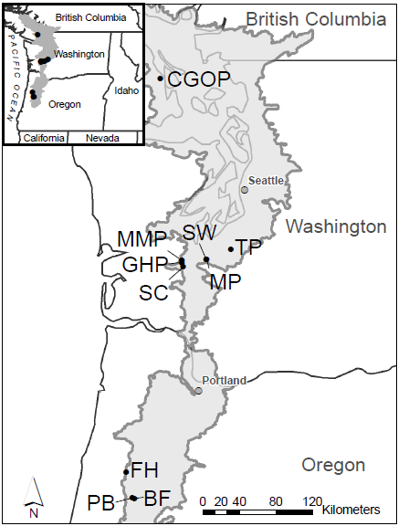

Figure 1 IAE/TNC research sites, ours are the southernmost sites, Pigeon Butte (PB), Bellfountain (BF) and Ft. Hoskins (FH)

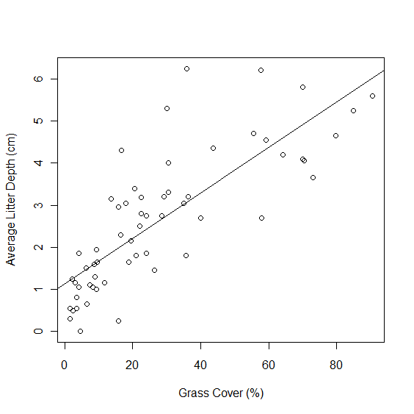

Figure 2 Litter depth compared with grass cover (p<0.0001, R2=0.33).

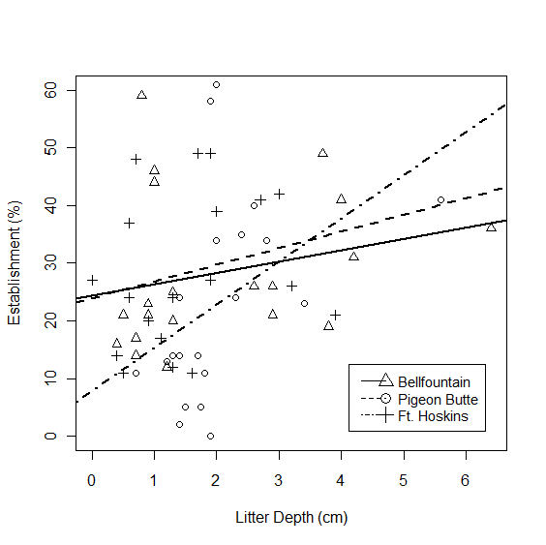

Figure 3. Establishment of *L. oreganus* relative to average litter depth at three sites (p=0.03, R2=0.11).

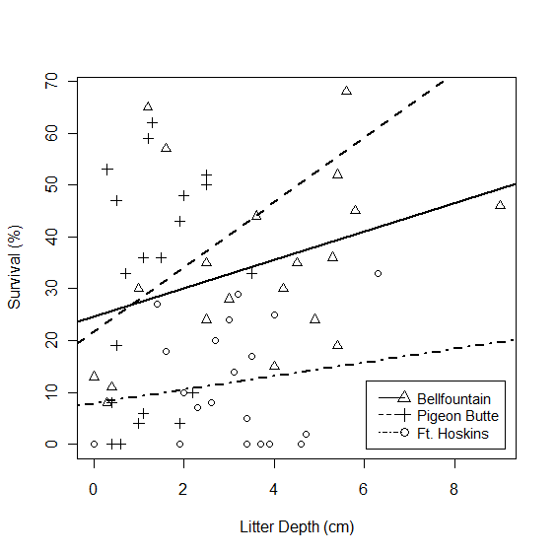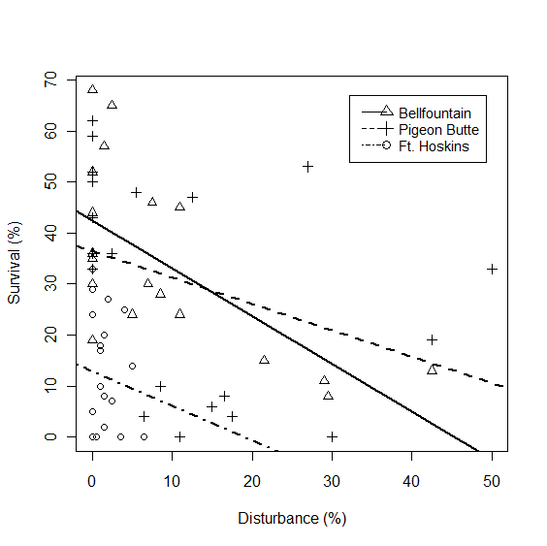

A)

B)

Figure 4. Survival of *L. oreganus* seeds compared to (left) litter depth (p= 0.05) and (right) soil disturbance from moles (p=0.0005).

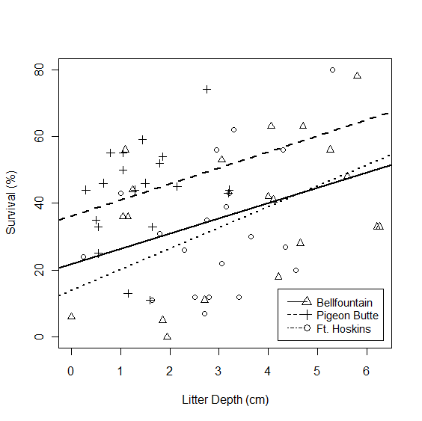

Figure 5 Survival of *S. malviflora* compared to litter depth at three study sites (p=0.004).

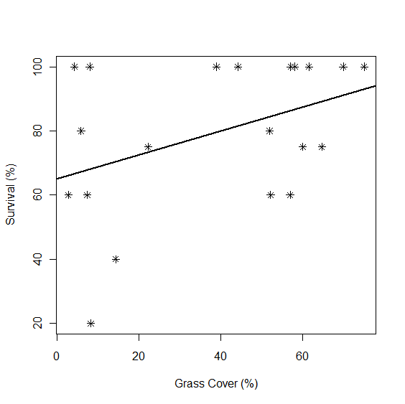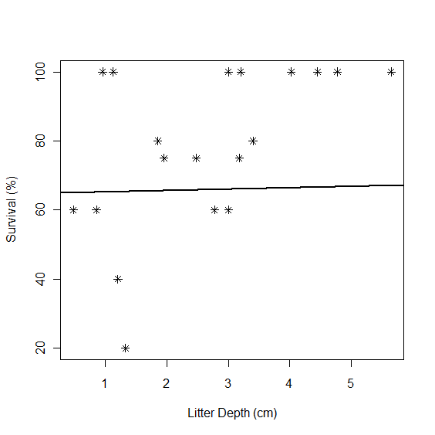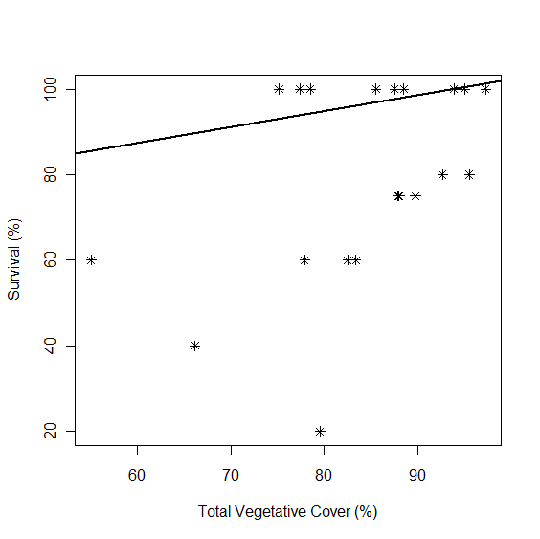

Figure 6. Survival of planted *Castilleja levisecta* as a function of cover of, from left to right, grass (p=0.07), total cover of vascular plants (p=0.04), and litter depth (p=0.01).

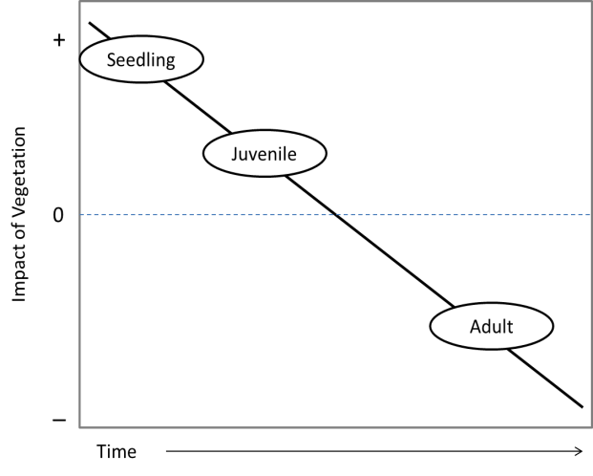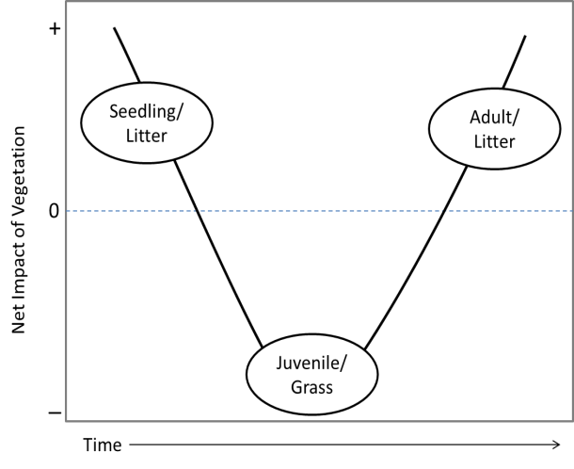

B)

A)

Figure 8. Two conceptual models of the shift between facilitative to competitive interactions with existing community over successive life history stages of an individual A) The net or driving interaction differs by functional group for different life history stages. B) The interaction with a single functional groups shifts in one direction with successive life history stages.